Unit - V

Factors Affecting Software Maintenance :-

Many factors directly or indirectly lead to high costs. A software maintenance framework is created to determine the effects of these factors on maintenance. This framework comprises user requirements, organizational and operational environments, maintenance process, maintenance personnel and the software products . These elements interact with each other on the following three types of relationships:  
**Relationship of Software product and environments :-**  
In this relationship, the software product changes according to the organizational and operational environment. However it is necessary to accept only those changes which are useful for the software product.  
**Relationship of the software product and user :-**  
In this relationship, the software product is modified according to the new user requirements. Hence it is important to modify the software that is useful and acceptable to user after modification.  
**Relationship of software product and the software maintenance team :-**  
In this relationship the software maintenance team members act as mediators to keep track of the software product. In other words, the software maintenance team analyses the modifications in other elements of software maintenance framework to determine their effect on a software product. These elements include user requirements, organizational and operational environments and the software maintenance process. All these elements affect the modifications in software and are personal for software quality.

User Requirements :-

Generally, users have little knowledge of lie software maintenance process due to which they can be unsupportive of the software maintenance team. Also, users may have some misconceptions , such as that support maintenance is like hardware maintenance, changing software is easy and changes cost too much and are time consuming .  
If the user requirements need major changes in the software, a lot of time may be consumed in implementing them. Similarly, users may opt for changes that are not according to the software standards or policies of a company. This situation creates a comfy between users and the rye yard maintenance team. Ty implement users' requirements in software the following points should be considered  
Feasibility: User requirements are feasible he the requested change in workable in the software system.  
Desirable: Before implementing new changes, it is important to consider whether the user modification request is necessary or not.  
Prioritized: In some cases the requirements may be both feasible and desirable. However, their requirements may not be of high priority at that time. In such a situation, the user requirements can be implemented at a later day.  
**Maintenance Process :-**  
Changes are implemented in the software system following the software maintenance process. The facets of a maintenance process which affect the evolution of software or contribute to high maintenance costs are:  
**Error detection and correction :-**  
It has been observed that error- free software is virtually non- existent. That is a software product tends to contain some line of ' residual' errors. If these errors are uncovered at the later stage of software development, they become more expensive to fix. The cost of fixing errors is even higher when errors are detected during the maintenance phase.  
**Difficulty in capturing change requirements :-**  
Requirements and users problems become clear only when a system is in use. Also users may not be able to express their requirements in a form which is understood to the analyst or programmer.  
Software engineering paradigm shift:  
Older system that was developed prior to the advent of structured programming technique to may be difficult to maintain.

**Software Maintenance Team**

A specific number of people employed to work together as a **team** each with the job description, job person specification, role, responsibilities and duties specific to a **maintenance team** member according to their employment contract and provide a variety of forms of **maintenance**

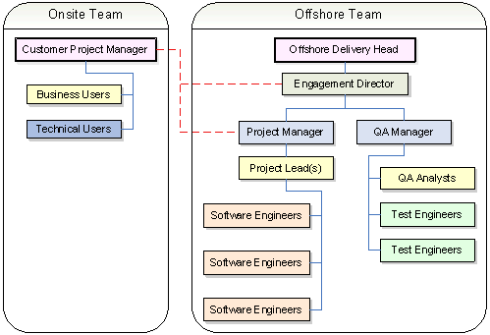

**Osborne Model of Software Maintenance :-**

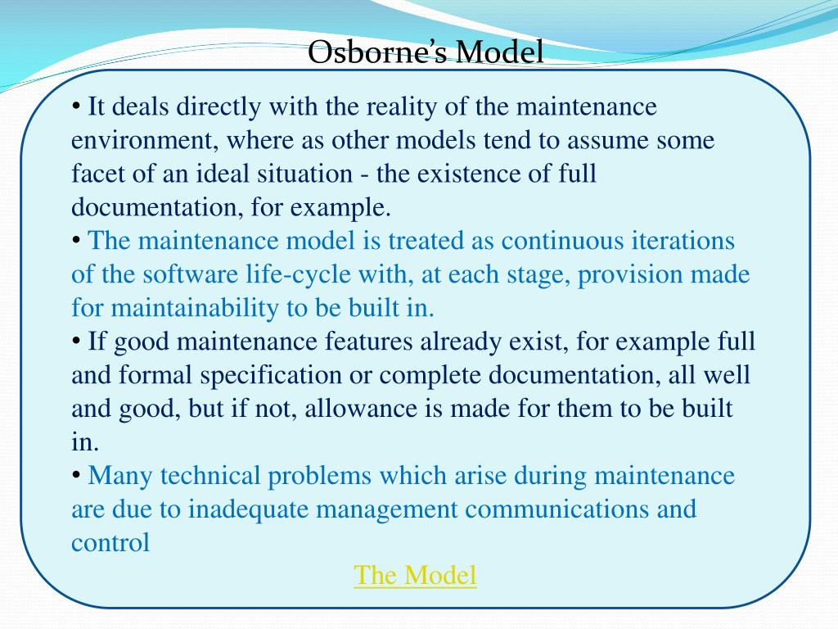

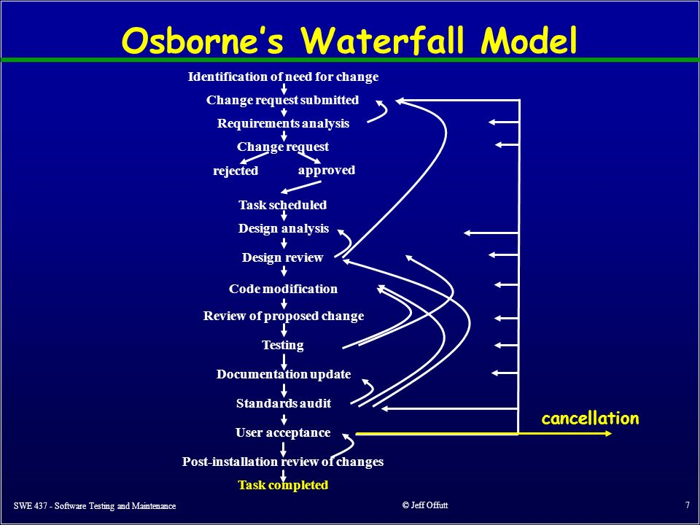

**Iterative Enhancement Model : -**

The **Iterative Enhancement Model** (also known as incremental **model** ) comprises the features of waterfall **model** in an **iterative** manner. ... The basic idea of this **model** is to start the process with requirements and **iteratively enhance** the requirements until the final software is implemented.

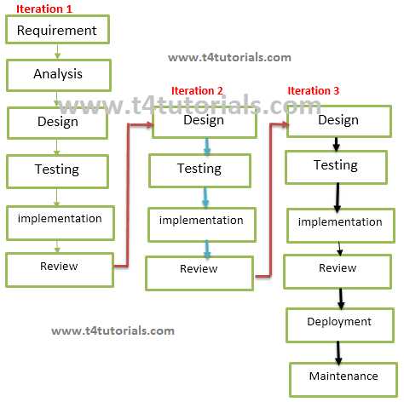

**The Reuse-Oriented Model :-**

**The reuse**-**oriented model**, also called **reuse**-**oriented** development (ROD), is a method of software development in which a program is refined by producing a sequence of prototypes called **models**, each of which is automatically derived from the preceding one according to a sequence of defined rules.

**Reuse-Oriented Software Engineering**

             Today some software is reuse able, we use basic architecture of system such as design, code etc and changes are made if required and incorporate into system. When people working on software project if design and code are similar to other software then we use that software and modify them according to our need and include them into their system. Today the use of existing software widely spread. Reusable software models save development time of the project.

Reuse –oriented software base on reusable components and integrated framework for the composition of these components, that components may provide specific function such as word processing and spreadsheet. Type of software components that is used in reuse-oriented software process are

Web services, Services standard are used for development these standard are available for remote.

Objects integrated with component framework, these object is created as a package.

Stand alone software system can be configured. That software is used in particular environment.

[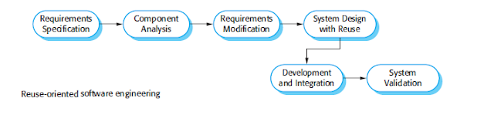](https://1.bp.blogspot.com/-7hmYNocrc_Q/VsrNPejVu0I/AAAAAAAAABc/C_8IRY9N71kJt9FgvpSK5a-o_R3DVvj0wCPcB/s1600/25-12-2013+12-57-43+PM.png)

**Diagram of reuse-oriented software**

 General process of reuse-oriented model are shown in figure

Requirement specification and system validation stages are general process used in different software process but other stages used in this model are different.

**1.**    **Component Analysis:-**

                                     According to given requirement, component is selected to implement that requirement specification. That is not possible the selected component provide the complete functionality, but that is possible the component used provide some of the functionality required.

**2.**    **Requirement Modification:-**

Information about component that is selected during component analysis is used to analysis requirement specification. Requirements are modified according to available components. Requirement modification is critical then component analysis activity is reused to find relative solution**.**

**3.**    **System design with reuse:-**

                                    During this stage the design of the system is build.  Designer must consider the reused component and organize the framework. If reused component is not available then new software is develop**.**

**4.**    **Development and Integration:-**

Components and COTS system are integrated to develop new software. Integration in this model is part of development rather than separate activity**.**

**Advantages and disadvantages of reuse-oriented model:-**

**Advantages:-**

1.    It can reduce the overall cost of software development as compared to other model.

2.    It can reduce the risk.

3.    It can save the time of software development. b/c testing of component is minimize.

4.    Faster delivery of software.

**Disadvantages:-**

1.    Reuse-oriented model is not always practical in its pure form.

2.    Compromises in Requirement may lead to a system that does not meet the real requirement of the user.

3.    Organization using the reusable component, are not able to control the new version of component, this may lead to lost control over the system evolution.

# What is a case study?

A case study is a research method to gain a better understanding of a subject or process. Case studies involve in-depth research into a given subject, in order to understand it’s functionality and successes.

Mostly importantly: case studies are stories. In particular, business case studies tell the story of how your product or service helped a person or a company achieve their goals.

As well as being valuable marketing tools, case studies are a good way to evaluate your product as it allows you to objectively examine how others are using it. It’s also a good way to interview your customers about why they work with you.

# Why should you write a case study?

Case studies are an effective marketing tool to engage potential customers and help build trust. By producing a case studies featuring your current clients or customers, you are showcasing how your tool or product can be used. You’re also showing that other people endorse your product.

In addition to being a good way to gather positive testimonials from existing customers, case studies are good educational resources and can be shared amongst your business or team, and used as a reference for future projects.

[**USE THIS CASE STUDY TEMPLATE**](https://venngage.com/templates/reports/teal-social-media-business-case-study-4305a330-8aa1-4416-9618-06bd37c023ee)

# Case Study Examples

## 1. Highlight the key take away from the case study

When creating a case study, you should identify the key takeaways from your research. Use catchy language to sum up this information in a sentence, and present this sentence at the top of your page. This is “at a glance” information and it allows people to gain a top level understanding of the content immediately.

[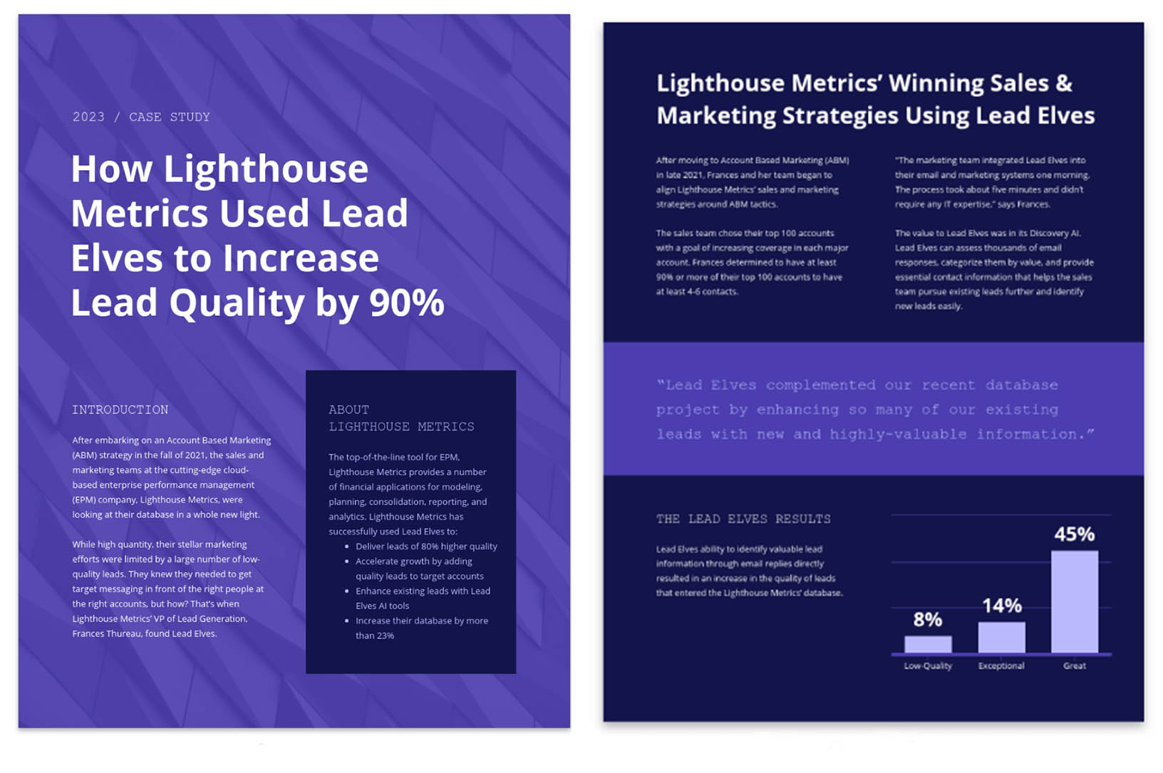](https://venngage.com/templates/reports/purple-saas-business-case-study-2077cd00-dce3-4360-bc78-8425babaec2e)

[**USE THIS CASE STUDY TEMPLATE**](https://venngage.com/templates/reports/purple-saas-business-case-study-2077cd00-dce3-4360-bc78-8425babaec2e)

You can use a large, bold, contrasting font to help this information stand out from the page and provide interest. Learn [how to choose fonts](https://venngage.com/blog/how-to-choose-fonts/) effectively with our Venngage guide and once you’ve done that, upload your fonts and [brand colors](https://venngage.com/blog/brand-colors/) to Venngage using the [My Brand Kit](https://venngage.com/blog/my-brand-kit/) tool and see them automatically applied to your designs.

The heading is the ideal place to put the most impactful information, as this is the first thing that people will read. In this example, the stat of “Increase[d] lead quality by 90%” is used as the header and makes people want to read more to find out how exactly lead quality was increased by such a massive amount.

If you’re conducting an in-person interview, you could highlight a direct quote or insight provided by your interview subject. Pick out a catchy sentence or phrase, or the key piece of information your interview subject provided and use that as a way to draw readers in.

## 2. Use icons to summarize information

In a case study you should use icons to highlight areas of your research that are particularly interesting or relevant, like in this case study example:

[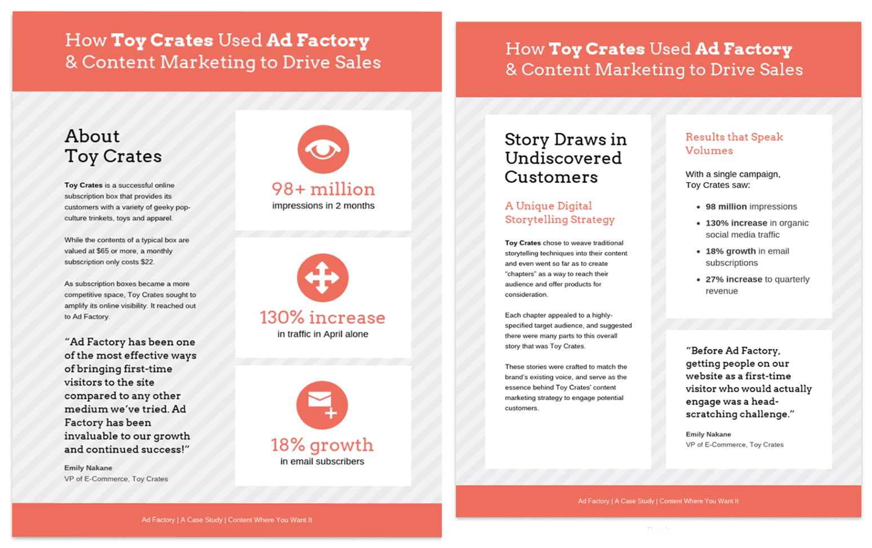](https://venngage.com/templates/reports/coral-content-marketing-case-study-b1f0c0d4-5578-4e32-9635-dd83afa135d4)

[**USE THIS CASE STUDY TEMPLATE**](https://venngage.com/templates/reports/coral-content-marketing-case-study-b1f0c0d4-5578-4e32-9635-dd83afa135d4)

Icons are a great way to help summarize information quickly, and can act as visual cues to help draw the reader’s attention to certain areas of the page. In the example above icons are used to represent the impressive areas of growth, and are presented in a way that grabs your attention.

**WATCH: Everything you need to know about…ICONS (in less than 3 minutes)**

## 3. Use data to make concrete points

When conducting any sort of research stats, facts, and figures are like gold dust (aka, really valuable). Being able to quantify your findings is important to help understand the information fully. Saying sales increased 10% is much more effective than saying sales increased.

In the case study blow the key data findings have been presented with icons, and stand out from the page. We can clearly understand the information and it shows that the case study has been well researched.

[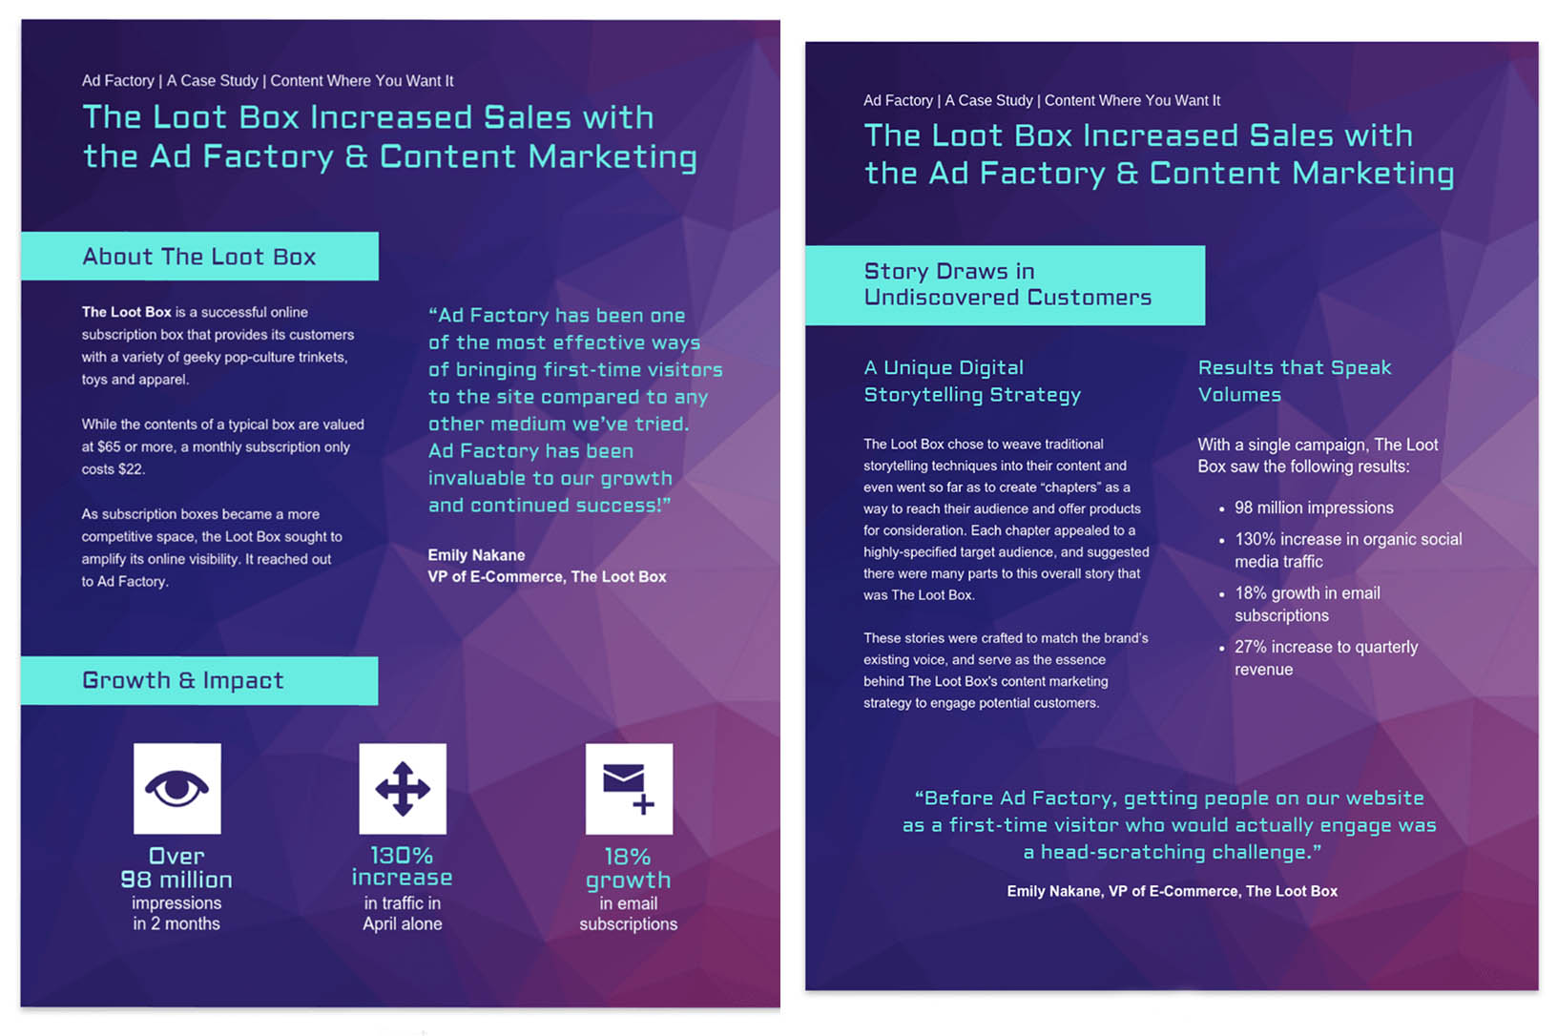](https://venngage.com/templates/reports/vibrant-content-marketing-case-study-175fe68d-2141-4815-874e-a2ce0e6492ad)

[**USE THIS CASE STUDY TEMPLATE**](https://venngage.com/templates/reports/vibrant-content-marketing-case-study-175fe68d-2141-4815-874e-a2ce0e6492ad)

## 4. Add direct quotes into your case study

To add an extra layer of authenticity you can include a direct quote from your customer within your case study. [According to research from Nielsen](https://contentmarketinginstitute.com/2017/06/strategies-customer-testimonials-content/), 92% of people will trust a recommendation from a peer and 70% trust recommendations even if they’re from somebody they don’t know.

[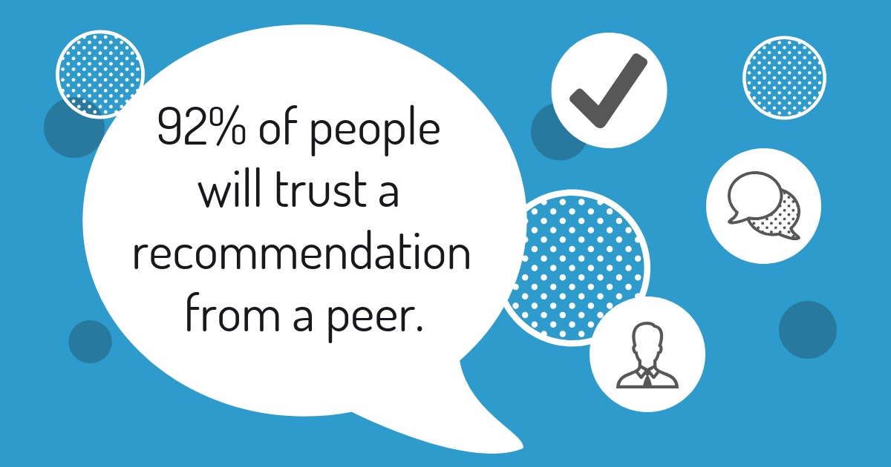](https://venngage.com/templates/social-media/motivational-creative-quote-linkedin-post-f9744a97-94e0-4668-a59c-0a4daaae38b8)

So if you have a customer or client who can’t stop singing your praises, make sure you get a direct quote from them and include it in your case study. You can either lift part of the conversation or interview, or you can specifically request a quote. Make sure to ask for permission before using the quote.

[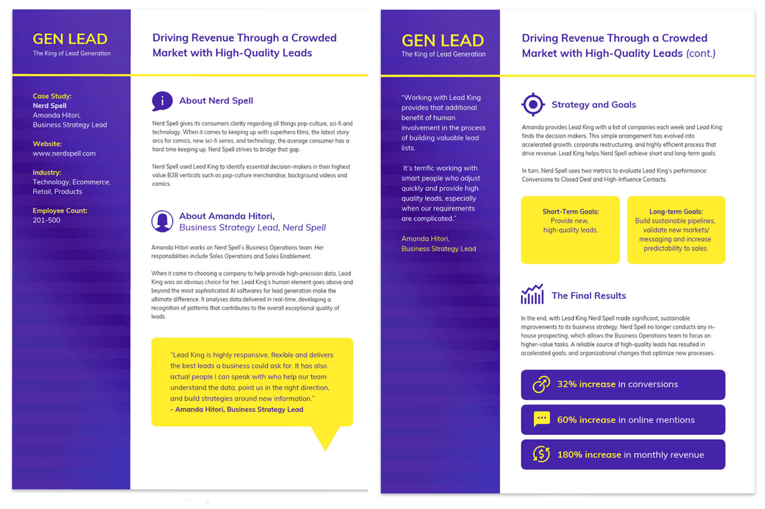](https://venngage.com/templates/reports/contrast-lead-generation-business-case-study-b20c0040-653d-4da6-8231-acb2a31d3d55)

[**USE THIS CASE STUDY TEMPLATE**](https://venngage.com/templates/reports/contrast-lead-generation-business-case-study-b20c0040-653d-4da6-8231-acb2a31d3d55)

This design uses a bright contrasting speech bubble to show that it includes a direct quote, and helps the quote stand out from the rest of the text. This will help draw the reader’s attention directly to the quote, in turn influencing them to use your product or service.

## 5. Use high contrast shapes and colors to draw attention to key information

Help the key information stand out within your case study by using high contrast shapes and colors. Use a complementary or contrasting color, or use a shape such as a rectangle or a circle for maximum impact.

[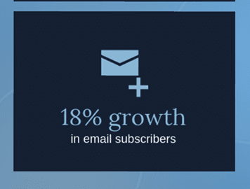](https://venngage.com/templates/reports/blue-content-marketing-case-study-7ac73168-e6db-4ec2-bd74-581a3a88b4e8)

This design has used dark blue rectangles to help separate the information and make it easier to read. Coupled with icons and strong statistics, this information stands out on the page, and is easily digestible and retainable.

[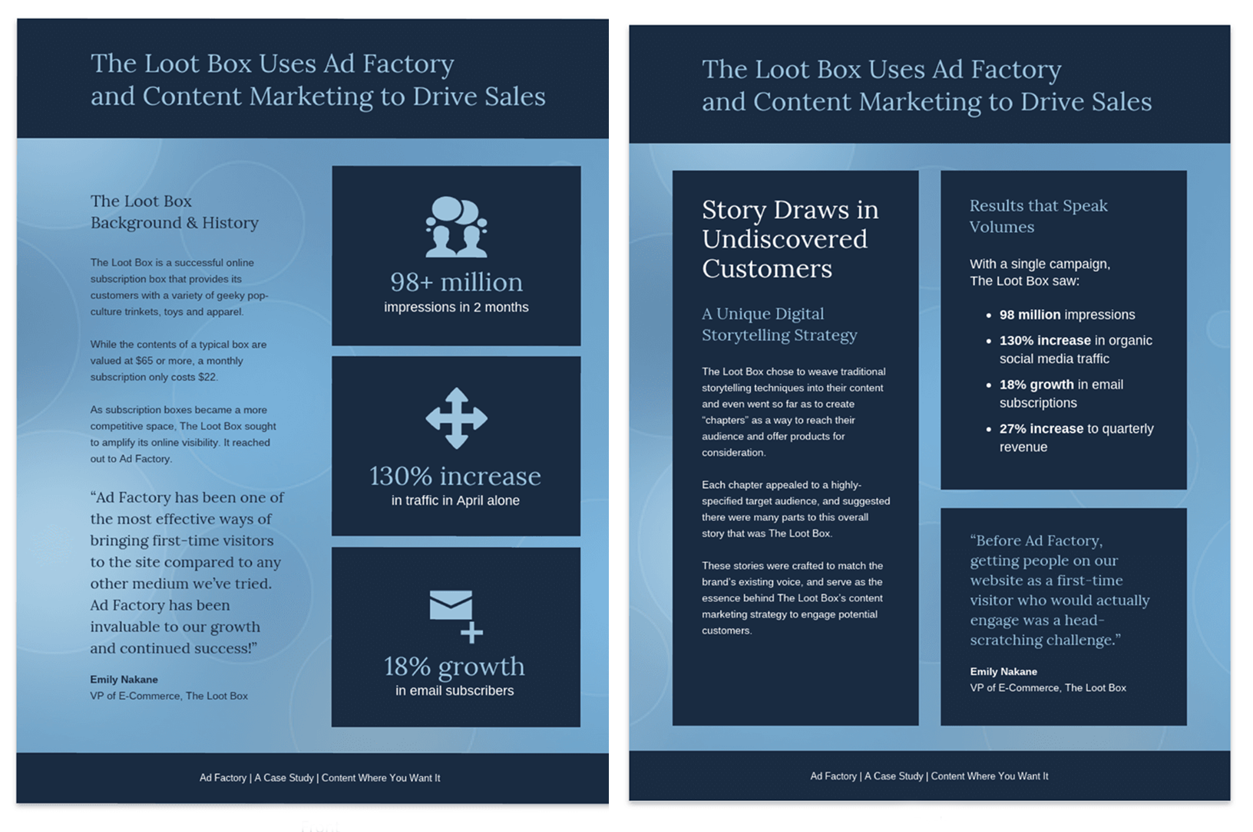](https://venngage.com/templates/reports/blue-content-marketing-case-study-7ac73168-e6db-4ec2-bd74-581a3a88b4e8)

[**USE THIS CASE STUDY TEMPLATE**](https://venngage.com/templates/reports/blue-content-marketing-case-study-7ac73168-e6db-4ec2-bd74-581a3a88b4e8)

## 6. Conduct a case study by researching the company holistically

When it comes to writing a case study, make sure you approach the company holistically and analyze everything from their social media to their sales. Think about every avenue your product or service has been of use to your case study company, and ask them about the impact this has had on their wider business goals.

[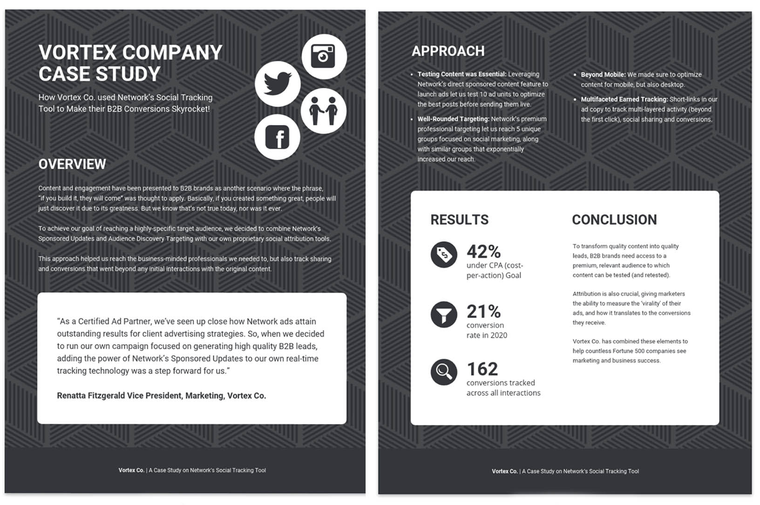](https://venngage.com/templates/reports/gray-b2b-content-marketing-case-study-752efb4f-93e9-45e9-96c8-e8ede21cc984)

[**USE THIS CASE STUDY TEMPLATE**](https://venngage.com/templates/reports/gray-b2b-content-marketing-case-study-752efb4f-93e9-45e9-96c8-e8ede21cc984)

In this B2B case study example, we can see that the company has been thought about holistically simply by the use of icons; by combining social media icons with icons that show in person communication we know that this is a well researched and thorough case study.

## 7. Cover short term and long term goals in your case study

When creating a case study it’s a great idea to look at both the short term and the long term goals of the company to gain the best understanding possible of the insights they provide. Short term goals will be what the company or person hopes to achieve in the next few months, and long term goals are what the company hopes to achieve in the next few years.

[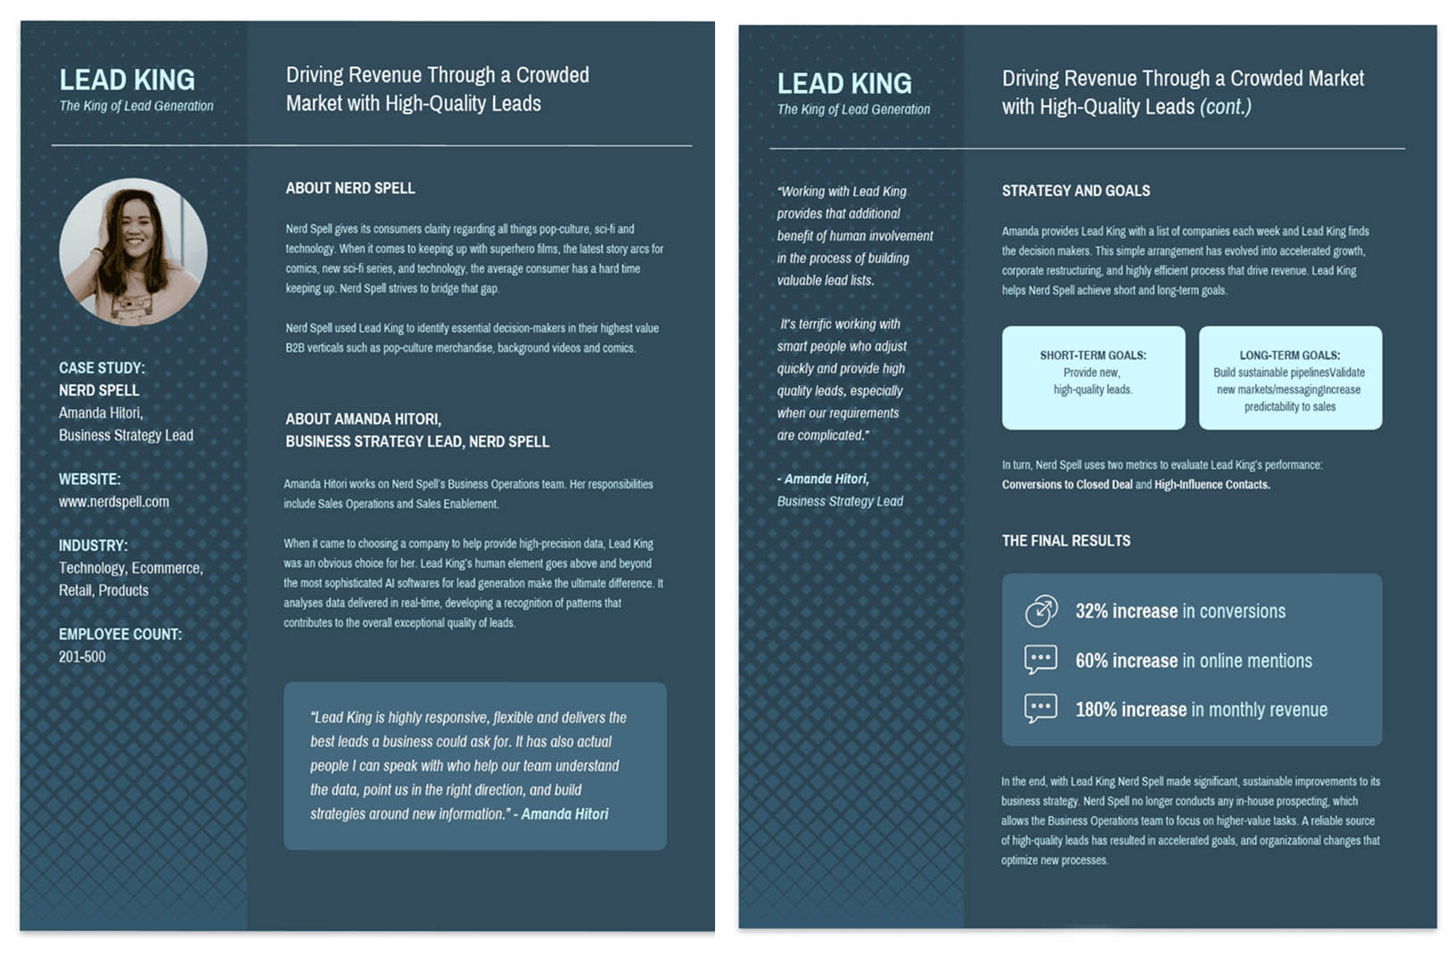](https://venngage.com/templates/reports/lead-generation-business-case-study-48b618be-9de7-4f6a-aadf-3f596a217386)

[**USE THIS CASE STUDY TEMPLATE**](https://venngage.com/templates/reports/lead-generation-business-case-study-48b618be-9de7-4f6a-aadf-3f596a217386)

In this case study example, the short and long term goals are clearly distinguished by light blue boxes, and placed side by side so that they are easy to compare.

[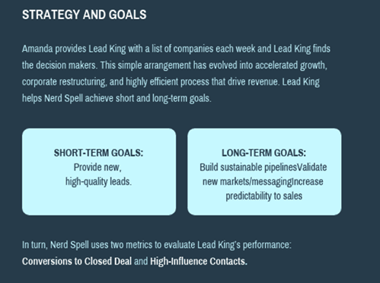](https://venngage.com/templates/reports/lead-generation-business-case-study-48b618be-9de7-4f6a-aadf-3f596a217386)

Use a strong introductory paragraph to outline the overall strategy and goals before outlining the specific short term and long term goals to help with clarity.

## 8. Use emotive, persuasive, or action based language in your case study

Create a compelling case study by using [emotive, persuasive and action-based language](https://copyhackers.com/2013/07/persuasive-writing-psychology/) when customizing your case study template.

[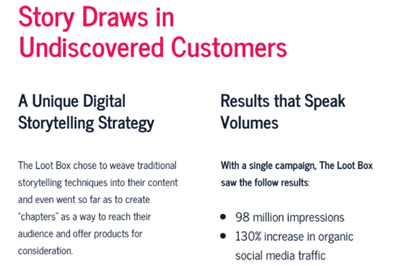](https://venngage.com/templates/reports/bold-content-marketing-case-study-28a6188d-2302-48a3-8512-5098e9bd009f)

In this case study example, we can see that phrases such as “Results that Speak Volumes” and “Drive Sales” have been used. Using persuasive language like this helps to inspire potential customers to take action now.

[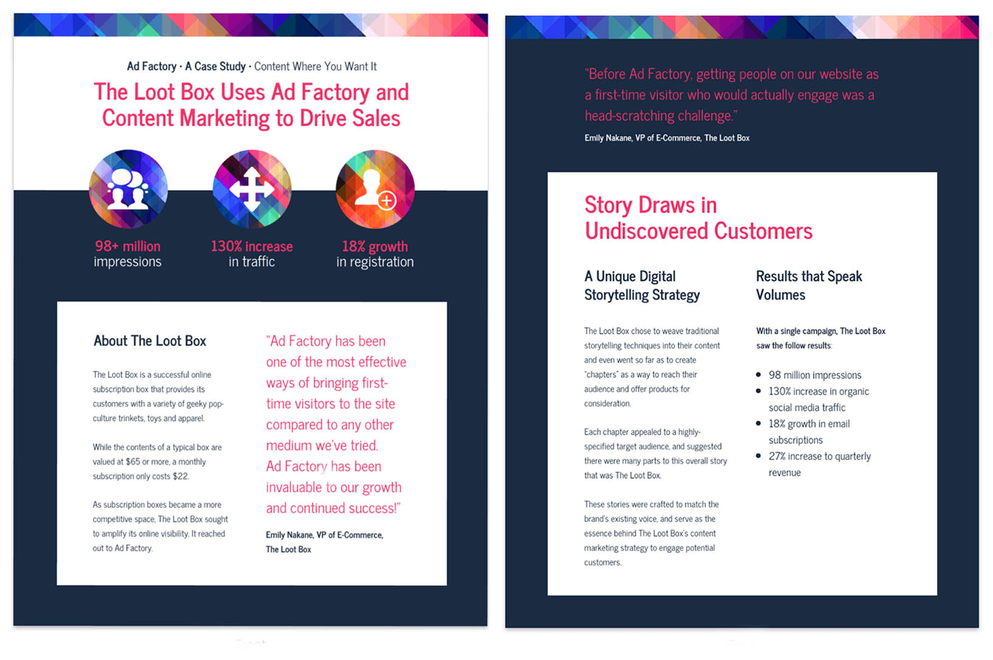](https://venngage.com/templates/reports/bold-content-marketing-case-study-28a6188d-2302-48a3-8512-5098e9bd009f)

[**USE THIS CASE STUDY TEMPLATE**](https://venngage.com/templates/reports/bold-content-marketing-case-study-28a6188d-2302-48a3-8512-5098e9bd009f)

## 9. Use a monochromatic color palette to create a professional and clean case study

Let your research shine by using a monochromatic and minimalistic color palette. By sticking to one color, and leaving lots of blank space you can ensure your design doesn’t distract from your case study content.

[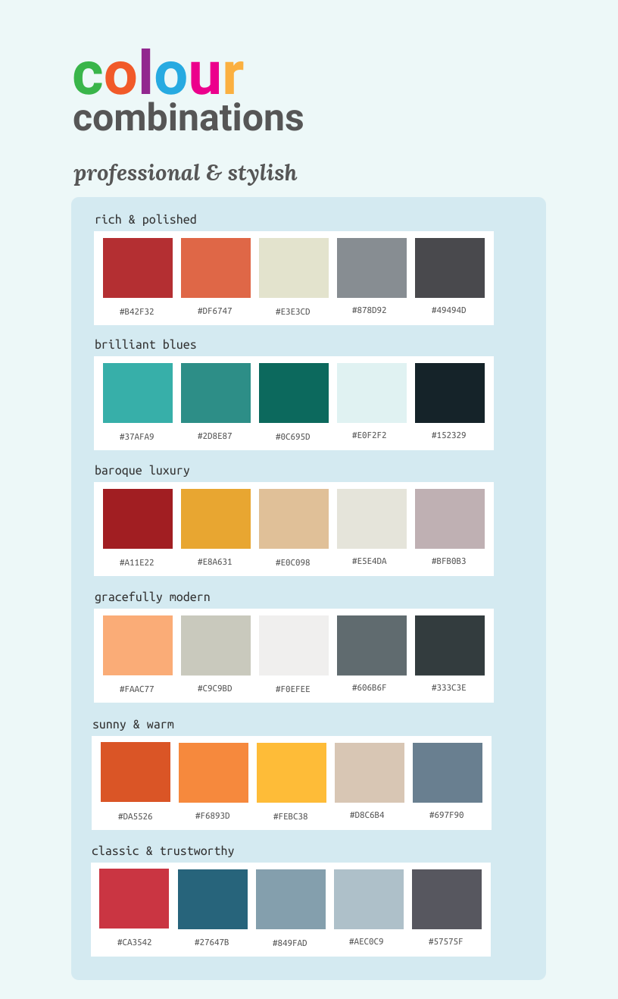](https://venngage.com/templates/infographics/color-palettes-dd1b862e-4294-4dac-bcda-324dd0a05360)

In this case study on Polygon Media, the design is simple and professional, and the layout allows you to follow the flow of information. The gradient effect on the left hand column helps break up the white background, and adds an interesting visual effect.

[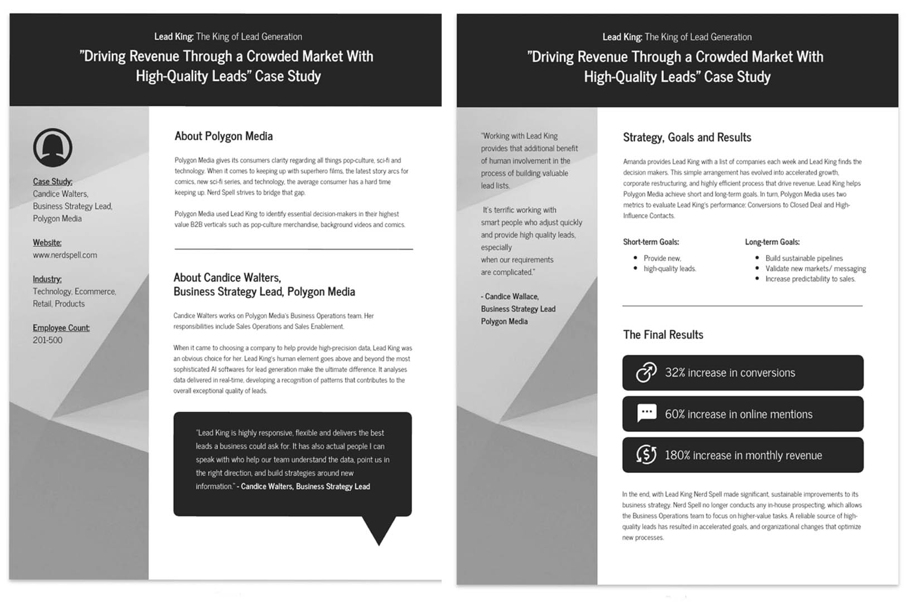](https://venngage.com/templates/reports/gray-lead-generation-business-case-study-5525cee8-6fbe-401a-9bca-8f00f28a9318)

[**USE THIS CASE STUDY TEMPLATE**](https://venngage.com/templates/reports/gray-lead-generation-business-case-study-5525cee8-6fbe-401a-9bca-8f00f28a9318)

## 10. Keep your potential customers in mind when creating a case study

[82% of marketers use case studies in their marketing](https://contentmarketinginstitute.com/2015/09/b2b-content-marketing-research/), because it’s such an effective tool to help quickly gain customers trust, and to showcase the potential of your product.

By creating a case study you’re telling potential customers that they can trust you, because you’re showing them that other people do. Not only that, but if you have a SaaS product, case studies are a great way to show how other people are effectively using your product in their business.

[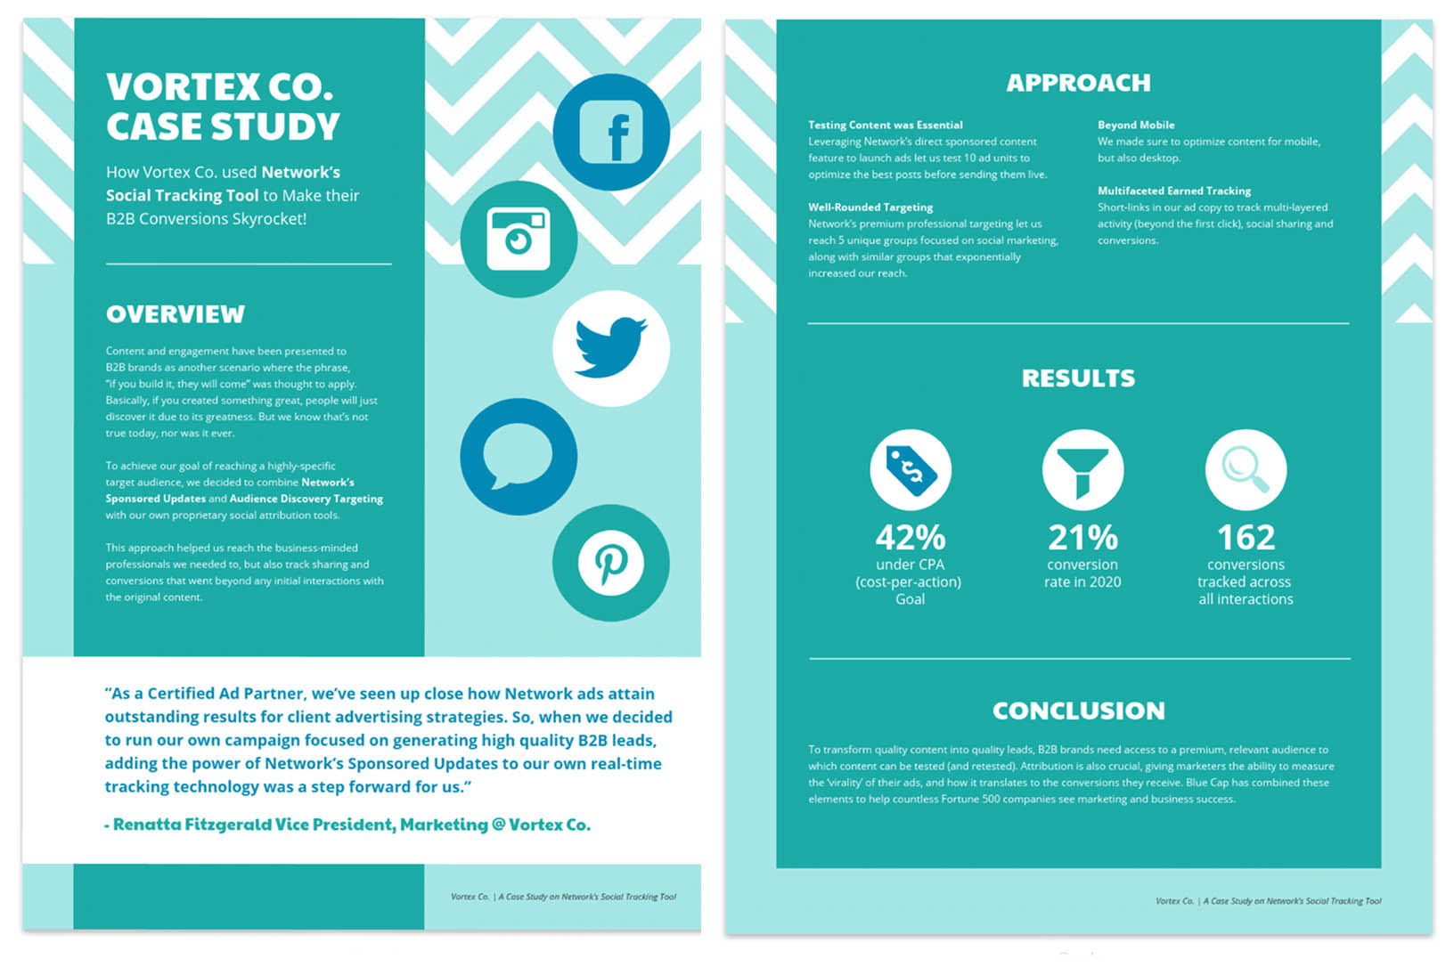](https://venngage.com/templates/reports/teal-social-media-business-case-study-4305a330-8aa1-4416-9618-06bd37c023ee)

[**USE THIS CASE STUDY TEMPLATE**](https://venngage.com/templates/reports/teal-social-media-business-case-study-4305a330-8aa1-4416-9618-06bd37c023ee)

In this case study, Network are demonstrating how their product has been used by Vortex Co. with great success; instantly showing other potential customers that their tool works and is worth using.